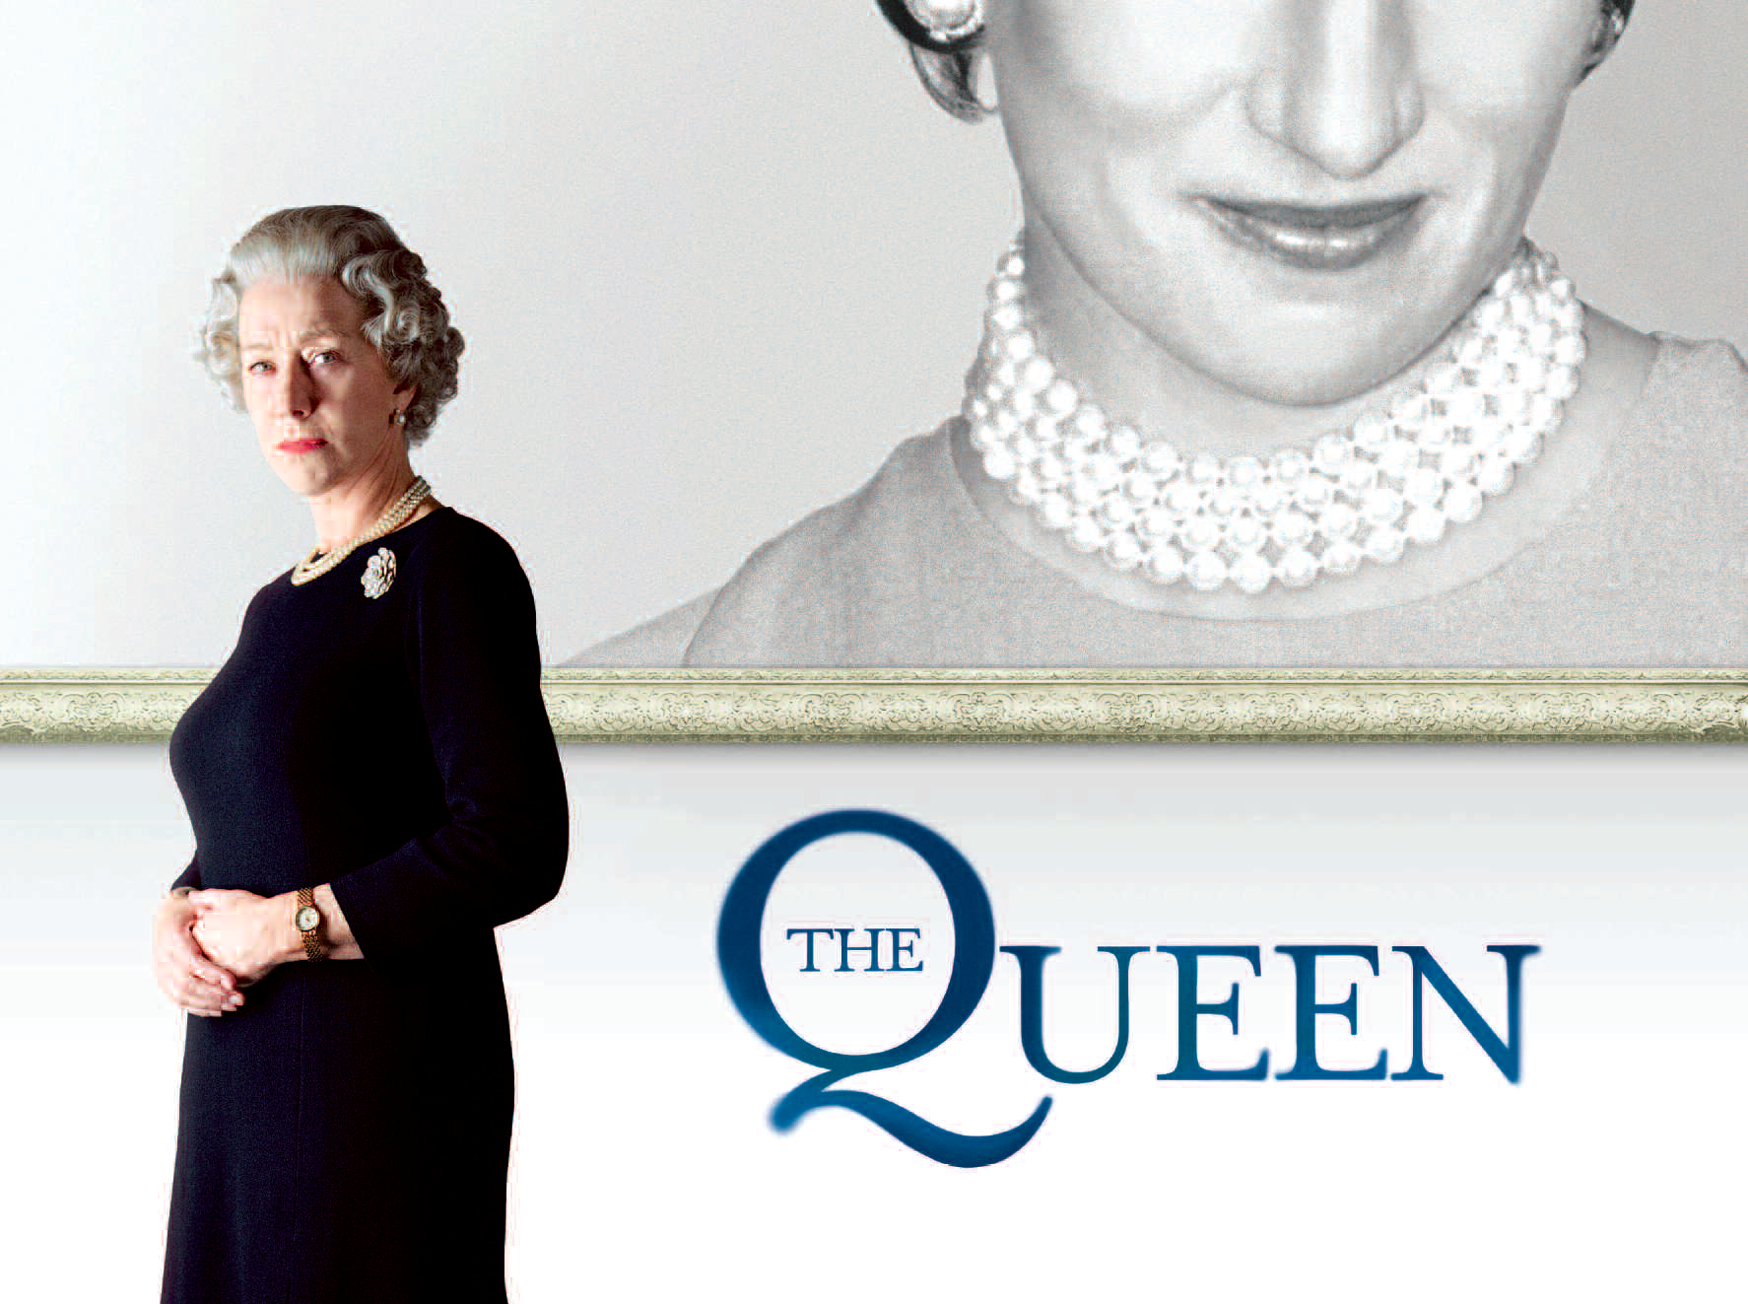

SYNOPSIS

When news of the death of Princess Diana, undoubtedly one of the most famous women in the world, breaks upon a shocked and disbelieving British public, Her Majesty Queen Elizabeth II retreats behind the walls of Balmoral Castle with her family, unable to comprehend the public response to the tragedy. For Tony Blair, the popular and newly elected Prime Minister, the people’s need for reassurance and support from their leaders is palpable.

As the unprecedented outpouring of emotion grows ever stronger, Blair must find a way to reconnect the Queen with the British public.

REACTIONS TO DIANA’S DEATH

Despite the film being about the Queen, we can see from the poster that Diana occupies more of the poster (on the first page) than the Queen herself. A major part of the film looks at Diana and how different groups responded to her life and death.

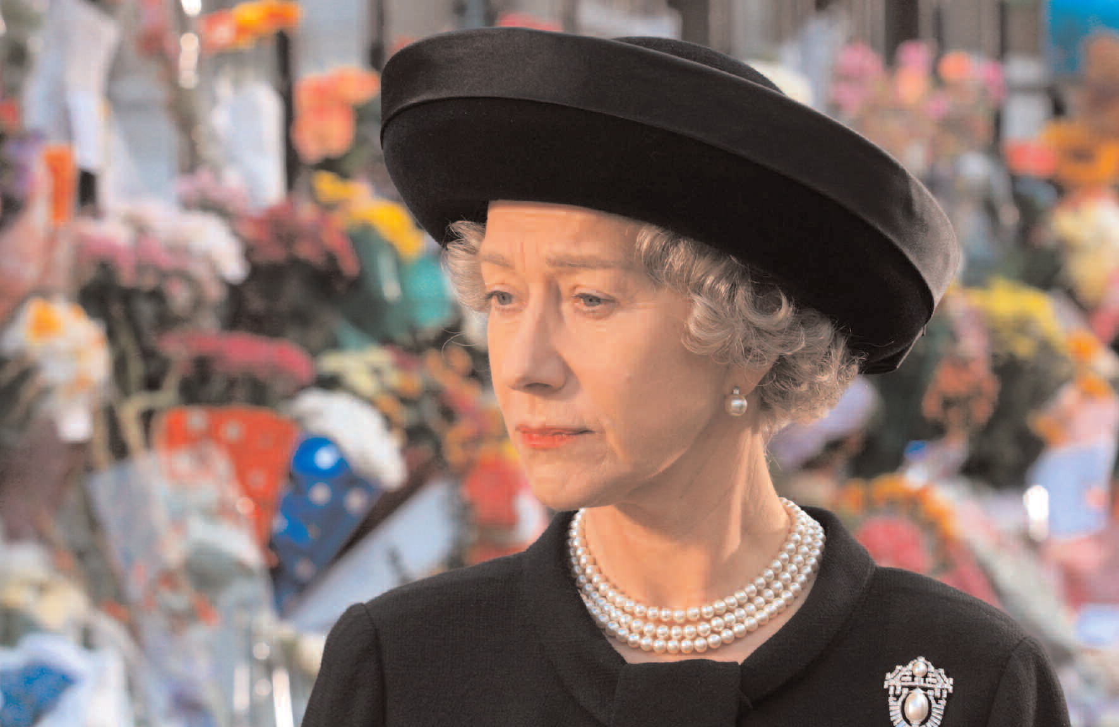

KEY QUESTIONS:

We can consider these groups:

1. The Royal Family
2. The British Government
3. The British Public

* Using key sequences from the film as evidence, make a list of adjectives to describe the behaviour of each of these groups.
* How important is the reaction of the public to both of the other groups? Can you find evidence from the film to support this?
* Are your views of the different groups the same as they were before you watched the film?
* Obviously these groups contain a wide range of diverse opinions; we see in the film that the Royals and the Government do not always share an opinion, and this is also true of the public. How does the representation of the public differ from the other groups? Why do you think this is?

WAYS OF REPORTING

Constant reference is made to newspaper reporting and media coverage in general, raising issues of managing events and setting agendas. How does this film provide insights into the way that various groups may manipulate media coverage?

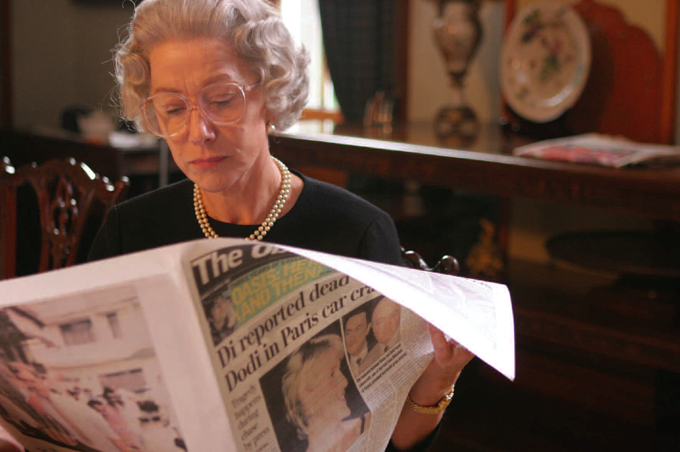

KEY QUESTIONS:

* What point(s) are being made about an intrusive press in this film?
* We have broadly considered the groups involved here. Are there patterns in the way that they are reported? Is there a sense that there are ‘good’ and ‘bad’ reports of the events that the film centers on? Think back to the headlines that are quoted by the various camps throughout the film. What do you think is driving the agendas of the different individuals?
* How does the Queen respond to newspaper/television reports? How is this different to other members of the Royal family?
* How does Tony Blair (the PM) respond to newspaper/television reports? How is this different to his advisors?
* How does the film portray any differences between behaving in a way that is popular and a way that is proper?
* Given aspects of the Queen’s personal history (information you have learned from the film) can you understand her motivations and actions in responding the way that she did?

PUBLIC INTEREST?

Can you imagine what it must be like to have everything that you do or don’t do (or say) recorded, photographed and discussed around the world? In the film, what kinds of interests are served by this kind of speculation and reporting?

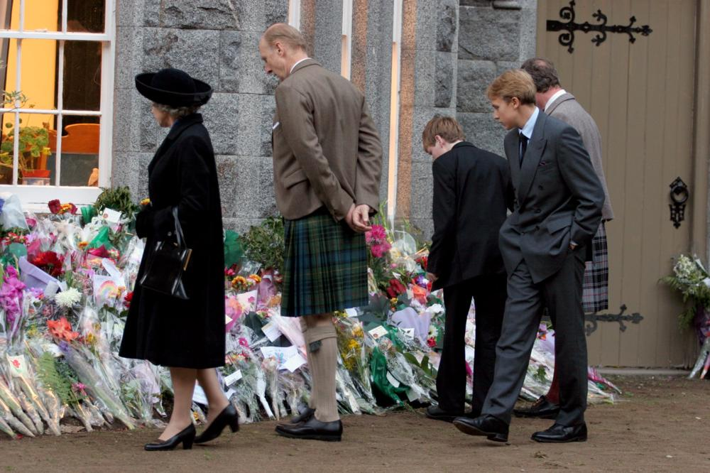

KEY QUESTIONS:

* Think of an event from your own life or that of someone you know (good or bad). Imagine it being reported and discussed around the world. How do you think that feels? Can you imagine reading an article that is completely untrue and/or very scathing? How would you react?
* What points are being made in the film about personal matters such as funeral arrangements and expressions of grief being legitimate areas for media coverage? With whom do your sympathies lay in the film – the Royal Family or the general public (explain your response referencing specific scenes from the film)?
* How powerful do you think these sensationalist media reports were in the film? Does the Royal Family get an opportunity to shake off perceptions that may possibly have been formed on false reports? Do you think this is fair or unfair?
* The film provides an account of an event that happened in 1997. Do you have any memories of this time? If so, are they in line with the opinions expressed by members of the public in the film?

REFLECTION

Helen Mirren, the actress who plays the Queen, received an Oscar™ and a BAFTA Film Award for Best Actress in a Leading Role. She says:

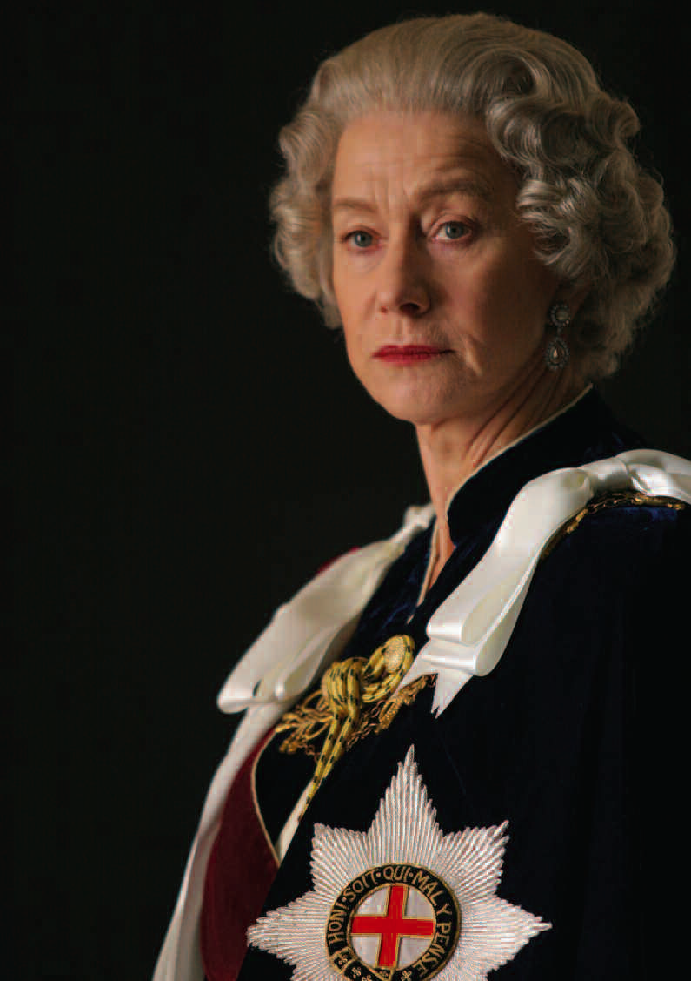

*‘I really got to love the Queen by playing her. I think she’s a person who is genuine, she refuses to be fake.’*

W Magazine, 2006

KEY QUESTIONS:

* Consider Mirren’s statement.
* Having watched the film, have your attitudes towards the Queen and the Royal Family as an institution changed?
* Does the film portray the Queen as a truly ‘genuine’ person?
* What does it suggest about a leader who lives such a high profile existence being able to juggle public duty with exhibiting personal feelings?